Hebrews 2:9 – 3:1 sermon, Tregear 19.2.2023

I’ve got 2 wonderful brothers – I have a big brother whose two years older than me and a younger brother whose just 16 months younger. After all I put them through, as we were growing up, I’m very fortunate that they still like me and care about me – we get on really well together. What’s it like in your family? George has three brothers, but she’s the eldest so she was able to boss them around when she was growing up – well, up to a certain stage.
If you had a brother what was he like? If you didn’t, maybe you had an idea of what you would like him to be like. About 75 years ago, just after World War 2, George Orwell wrote a novel called 1984. He imagined a world where there was just one party ruling and there was this person called Big Brother. People were told that Big Brother was watching over them. No one ever saw Big Brother but the idea of Big Brother was sufficient to keep the people living in a state of fear, so that they would not want to disobey him. The idea was that Big Brother was watching your every move, in every place you were in, you couldn’t escape him. The Big Brother TV show kinda uses that idea as well.
Well I don’t know if you noticed that in the passage today, those who are followers of Jesus are called Jesus’ brothers and sisters. If you are a follower of Jesus you are also a brother of Jesus. Have you ever thought of that?
This is an amazing 10 verses that we’re reading today. If this was all that you read for the rest of this year, and thought over it, pondered its meaning and sought to live out what you learn here you would be doing well.
So we better get into it.

We finished last week with v.9 – v.5-8 we learn that humans didn’t measure up to the description of men and women in Psalm 8. We were supposed to rule over the earth but we get buried in it, because of our sin. But, then v.9 – BUT we see Jesus, Jesus crowned with glory because he suffered death; he tastes death for everyone. And the next 8 verses are going to expand on this.
In v.10 – By his death on the cross Jesus brought many sons and daughters to glory – that’s all those people who trust in what Jesus did on the cross and begin the journey with Jesus, with God, of becoming his family. Ok, we’re then reminded that everything exists FOR him and
THROUGH him. A huge statement isn’t it. And God made Jesus, who is described as the pioneer or founder of our faith, God made him perfect, and he was made perfect through what he suffered.
Whoah, hang on a minute I can hear you say – Jesus MADE perfect. I thought Jesus was already perfect when he came to earth as a man. Well, it wasn’t to do with him sinning or not sinning; it was to do with him being just the right person, the perfect person for the job that God had given him – that was to die on the cross. So it’s not about Jesus’ moral perfection – it’s that he was effective as our representative. And how does this happen? It happens through his suffering. You might have noticed that this word “suffering” keeps appearing. Have you thought about what that means? What makes Jesus perfect, the right person for his job of saving the world. He must have a university degree – No; he must have accomplished a lot, been a successful businessman maybe – No, he doesn’t even have a place to live in, to call home; did he get awards from the Sanhedrin – No, they put him on a cross. No, what the father sees in his life are his scars – the wounds he carries; the suffering he goes through. This is what makes him our perfect representative! Boy, that speaks to me. The words of Isaiah ring out from chapter 53 - Surely he took up our pain and bore our suffering,
yet we considered him punished by God, stricken by him, and afflicted. ⁵ But he was pierced for our transgressions, he was crushed for our iniquities; the punishment that brought us peace was on him,
and by his wounds we are healed. This is my God doing this for me – it’s all upside down isn’t it? But this is what God does.
Brennan Manning wrote - On the last day, Jesus will look us over not for medals, diplomas, or honours, but for scars. It is not by our gifts, insights, success, ideas, or qualifications that God is determined to heal the world, but by our scars. By his wounds we are healed, and by our wounds the healing is shared. (p.86)
And if what we’ve read so far is not enough to blow your mind, we come to v.11 – Both the one who makes people holy (ie Jesus) and those who are made holy (those who are disciples of Jesus), are of the same family. Jesus and us are of the same family; so Jesus is not ashamed to calls us brothers and sisters. Why would he have shame in calling us brothers and sisters – well you and I know – we know what we’re like, proud, selfish, mean spirited. But through what Jesus has done on the cross he has made us shame free; we’re a shame-free zone. If we are in Christ he does not feel any shame in us – he has taken our shame on the cross. And so he calls
us brothers and sisters. Purely because of what he has done for us – he has made us holy. Are you gob-smacked?!! Have you heard anything like this before? The creator and the sustainer of the universe has suffered and died for us that we might be known as his brothers and sisters. You couldn’t make this stuff up – it’s ridiculous and yet it’s true.
But we aren’t finished here. v.12 – The writer has Jesus quoting from Psalm 22:22 where Jesus is saying that he will declare our names to the church and sing our praises. What! That’s ridiculous!!! Jesus’ holiness has become our holiness – his holiness makes us part of the same family – God’s family – so that Jesus can call us brothers; and then in v.13 the verses from Isaiah 8 originally referred to Isaiah’s children but the writer now applies them to what Jesus says about his children – the children God has given me.
Jesus our big brother – not the 1984 big brother or the TV big brother. Yes, he does know everything that is happening to us, but what a different big brother. It’s like the writer is saying, “Well, go back to Judaism if you like. But will you ever find a brother like this. You want a big brother who will watch over you; who will stand up for you against the bully; who’ll put your interests before his own, in fact he’ll die for you. this is the big brother you longed for.
I remember Tim Keller writing about the story of the Father and the 2 sons – you remember, the younger son takes his inheritance and goes off. Eventually he comes back. Where is the big brother? He is out in fields sulking and angry that his father has accepted back his younger brother. Where should the older brother have been? He should have been out finding the younger brother. Jesus is the older brother who does go out and find the younger brother, us, and brings us home. In the process he suffers much and dies for us. This is our big brother.

Now v.14 – Since the children have flesh and blood ( very earthy image here) , he, too, ( ie Jesus) shared in their humanity so that by his death he might break the power of him wh holds the power of death – that is, the devil – and free those who all their lives were held in the slavery by their fear of death.
Jesus shares in our humanity so that by his death he could break the power of Satan who holds the power of death. And he frees us from the fear of death, but not just the fear of death, but all fears. This is such a powerful truth. No one has defeated death – only Jesus. We need no
longer fear death or anything else because Jesus has broken Satan’s power; and he’s our big brother. I think that this is an incredibly significant truth so I want to show you how this works in my life.
So here’s my timeline
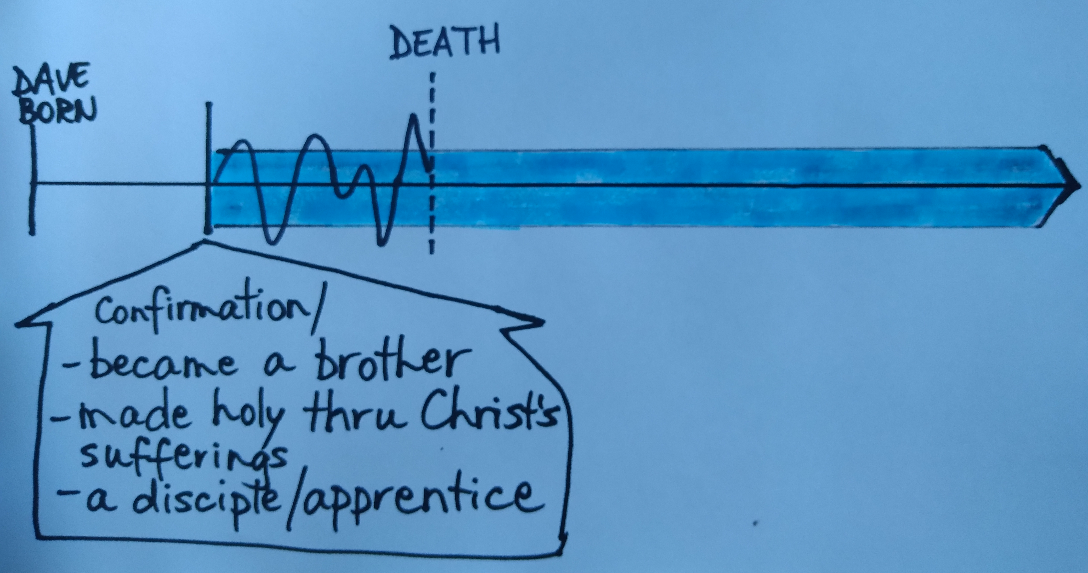
oh yes, and there’s death. The world thinks it all ends at death and so we have to live life to the full up till we die. But Jesus says; the Bible says, that we have become Jesus’ brother when we become a follower. There is a little blip called death but I’ve started the journey with Jesus – I am already his. And I live now as if I will live forever – because I will. It’s not life ends when I die; it’s I become complete when I die – fully able to enjoy relationship with God. Let me tell you this is not how the world views death. But this is how God views death. Death has been defeated. As Paul says in 1 Corinthians 15, because of Jesus’ resurrection, death where is your sting - death you are defeated.
Just quickly, in v.16, notice that Jesus doesn’t die for angels, he doesn’t help angels, he helps us humans – he saves us, not angels. Not only is he greater than angels. But he also does something for us that he doesn’t do for angels.
These last 2 verses of the chapter, they’re packed full of significant details about what Jesus has accomplished for us. In v.17 we read that he had to be made fully human IN EVERY WAY, so that he could be a faithful high priest making propitiation for our sins. And then in v.18 – Because he suffered when tempted, he is able to help those who are being tempted, ie us.
Ok, why is this significant? Firstly, Jesus is a human, which means he can represent humans and make a perfect sacrifice for us. Second, he really has experienced the life of a human, which means he can understand us and perfectly intercede, or intervene, for us. We’re going to think more about the role of the high priest later on in this book but for now let’s just remember that the high priest would make a special sacrifice on behalf of the people once a year every year. But it was never enough. The other problem was that the high priest would die, then there would be another high priest. Some high priests were good, and some were not good, so they were unreliable. Jesus has become our reliable high priest, who dies just
once. He IS the priest and he IS the sacrifice. Once and for all. And this is where the writer uses this word “propitiation”.
The Greeks worshipped many gods. They used this word which meant that you tried to make your god propitious, or favourably disposed towards you – you’re trying to get the god’s goodwill. The gods did not have goodwill towards you, they were often grumpy old things, so you had to do something to earn their favour, stop them bring grumpy – you know bring them offerings, do a good deed, worship 20 times a week, every week for 3 years or something like that. But it was something you earned. So the writer is using this term, but he is writing about the one true god who is so different from the Greek gods, who were made up gods. We cannot do anything to appease the holy anger of God. But God has done something by sending the perfect one, Jesus, to be our merciful and faithful high priest and HE makes propitiation for our sins. God is always the same; he isn’t grumpy one day, and nice and loving the next. He doesn’t have mood swings like us. God is right to be angry at sin, but we do not need to fear that anger.
We think of anger as someone losing it. Like you’ve done this to me. I’m so angry I’m going to get you back. This is nothing like the anger of God. His anger comes out of a heart of justice. What you’re doing is wrong; it can’t be just ignored. Justice demands a response. God’s anger is a righteous response to the wrong that’s been committed. But what God does is he sends his Son, Jesus, who turns away God’s anger. He makes propitiation for our sins. For those who trust in Jesus, the wrath or anger of God is turned away. It has been totally satisfied by Jesus’ death. God’s favour now rests on you, and you do not need to be afraid.
Just a few quick words about how Jesus is able to help those who are being tempted. Jesus suffered greatly while he was on earth. Nobody ever looked at jesus’ life and said, “I wish I had a life like that.” He had a brutally hard existence. This is critical to understanding why he is such an effective high priest: because he can relate to you and me. Jesus experienced everything we experience.
Have you ever felt abandoned or lonely? Jesus can relate: he is the “man of sorrows” as we heard before, rejected and put to death by his own people.
Ever felt the grief of losing someone you love? Jesus can relate to that: he wept at the death of Lazarus.
Ever been lied about? Jesus can relate: he was betrayed by a close friend, falsely accused by the priests, and ridiculed by the soldiers.
Ever had money problems? Jesus was poor and had nowhere to lay his head.
Ever felt misunderstood by a family member? Jesus’ own family thought he had lost his mind.
Ever felt highly stressed? Jesus was so stressed in the Garden of Gethsemane that his sweat was like drops of blood.
No one can ever go to Jesus and say, “You don’t understand my life.” It’s us who cannot understand how much HE suffered in HIS life.
This is our big brother. He knows what is happening in your life right now. We can come to him with our fears, our worries, our disappointments, our joys. He understands what it is like to be tempted. He’s our big brother, who has come looking for us; who has rescued us; who has paid the price; who has become our propitiation by his suffering and death.
Can you think of anyone else you would rather have as your rabbi, your teacher, to follow in his footsteps, to follow in his dust? Do you need to talk to Jesus about the journey you are on? Have you come back and responded to his call to you to follow him? Don’t leave here this morning until you’ve talked with Jesus. Is there something you need to talk with him; thank him for right now.

